**Ithemba – Ray of Hope User Manual**

**System Concept**

This is a burial society application. At its heart is a database that is used to store details of clients that are captured using the application’s graphical user interface. Before a client can register for a policy, they must first create a login account. This is also true for administrators before they can add, view, update, or delete clients.

**System Use Case Diagram**

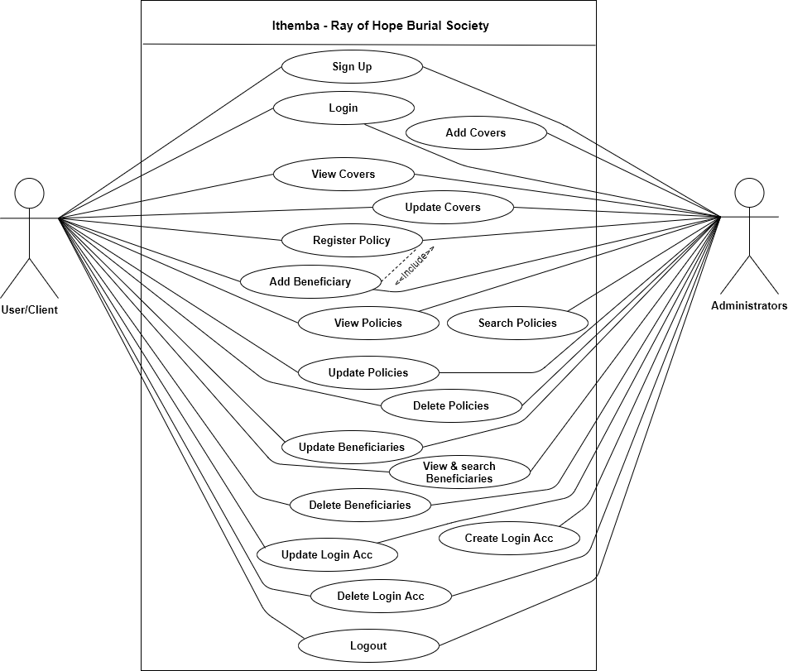

**User Manual**

**Ithemba – Ray of Hope Login Form**

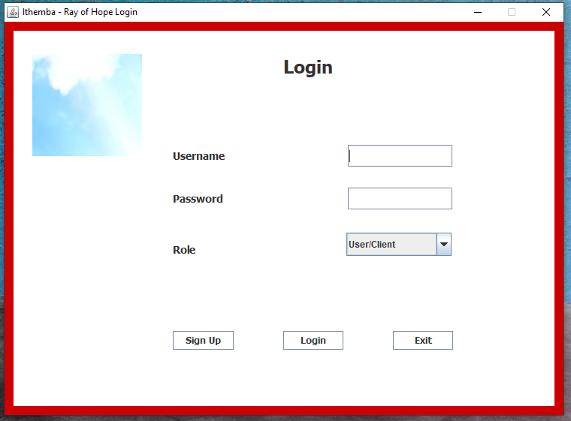

The login form allows users of the application to sign up for a new login account, and log into the system. The form has three buttons, as follows:

* **Sign Up** – this button displays a form for users to sign up.

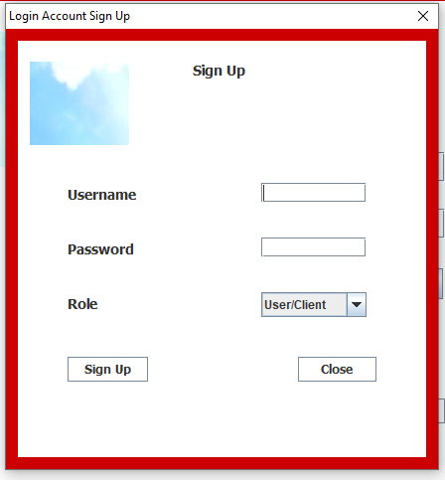

This dialog form allows users to sign up for a login account by providing a username, password, and user role

* + - **Sign Up** – uploads to the database login account details of a user.
    - **Close** – disposes of this dialog form.
* **Login** – this button of the login form logs into the system a user and display the main application window.
* **Exit** – this button terminates the application run.

**Ithemba – Ray of Hope Application Main Window**

**Default Administrator**

When a default administrator is logged in, using the **username**: Siviwe, and **password**: 11HA1900486, the main application window is displayed as follows:

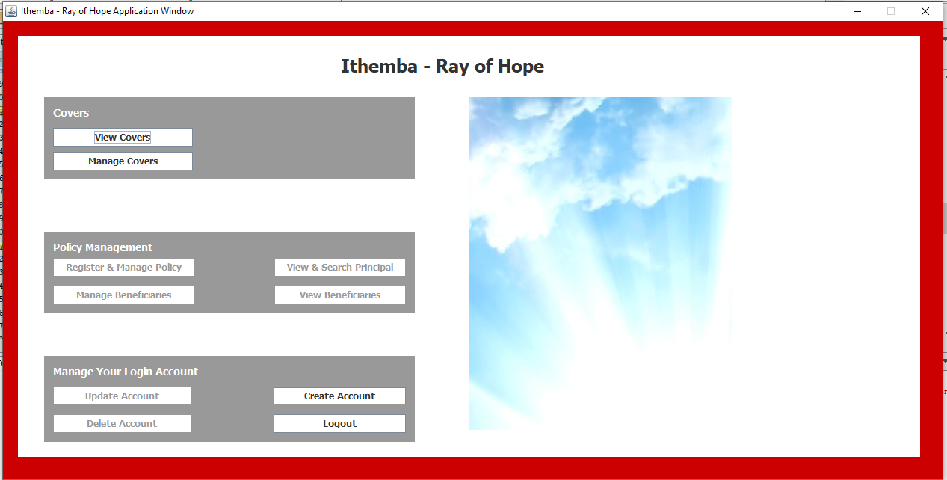

**Signed Up Administrator**

When a signed up administrator is logged in, the main application window is displayed as follows:

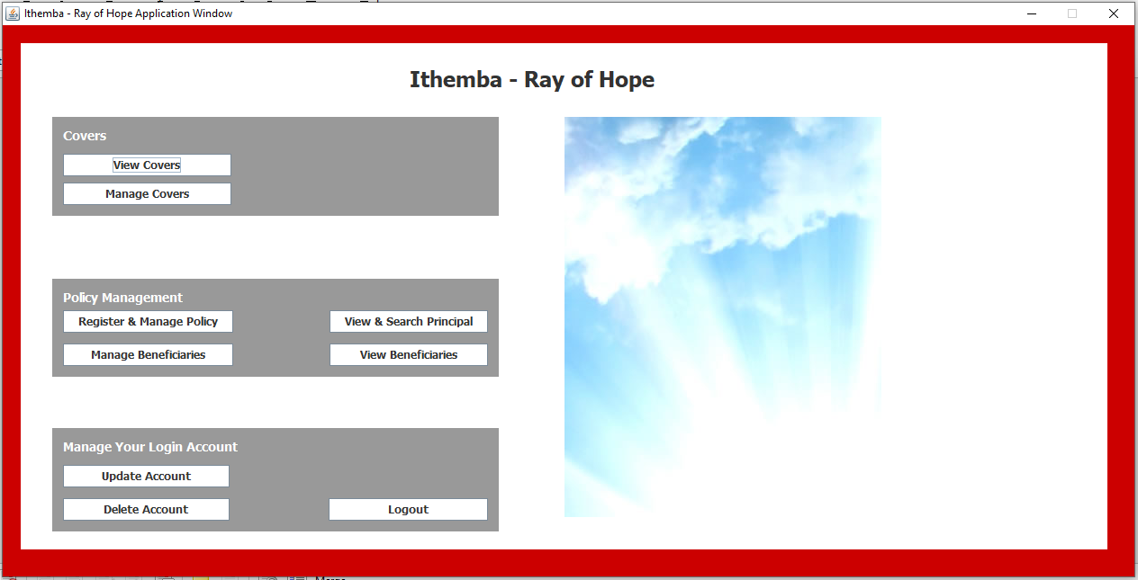

The functionality of the Main application window buttons when an administrator is logged in is as follows:

* **View Covers** – this button displays a dialog to view covers.

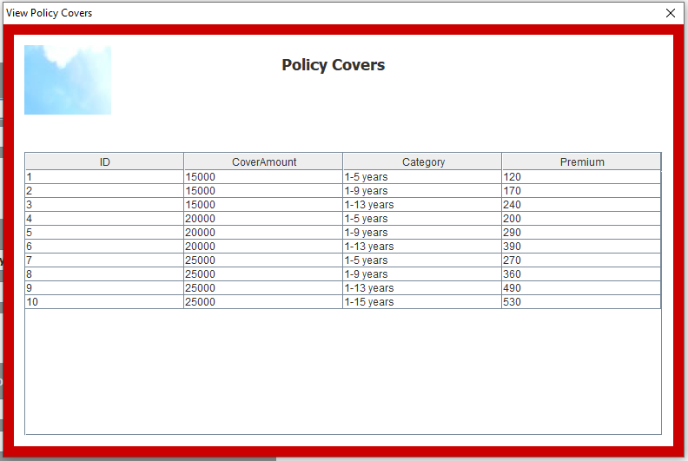

* **Manage Covers** – this button displays a dialog to add and update policy covers.

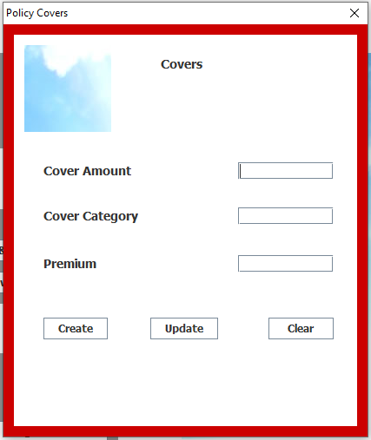

* **Create** – this button uploads to the database policy cover details.
* **Update** – this button sets details of a policy cover to the graphical user interface (GUI), it then change its text to **save**. When the button text is **save** and it is selected, it uploads updated policy cover details to the database.
* **Clear** – this button clears text in the GUI text fields.
* **Register & Manage Policy** – this button displays a form to register a client for a policy and manage clients policy details.

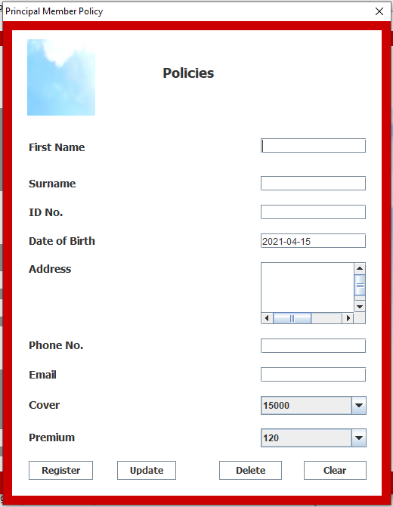

* **Register** – this button uploads to the database policy details of a client being registered.
* **Update** – this button set details of a policy member to the GUI, it then changes its text to **save**. When the text is **save**, the form uploads to the database updated policy details of a client/principal member.
* **Delete** – this button deletes details of a principal member from the database. If the principal member has registered beneficiaries, these are also deleted.
* **Clear** – this button clears text in the text fields of the GUI.
* **View & Search Principal** – this button displays a form to display policy details of principal members, it also allows searching of principal members’ policy records.

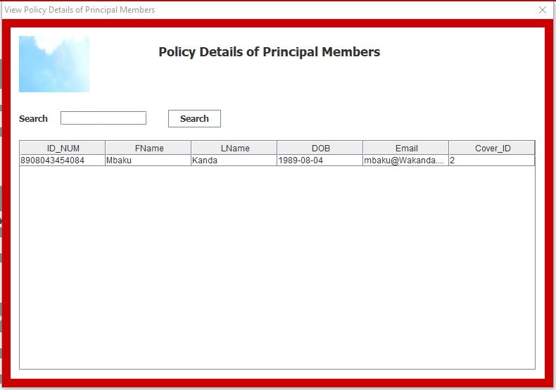

* + **Search** – this button searches the database for a principal member(s) using the first and last name or one of the two. It then displays the results on the table and changes its text to **clear**. When the button text is **clear** and selected, it clears the search text box and updates the table to display all principal members again.
* **Manage Beneficiaries** – this button displays a form to register and manage beneficiaries’ details.

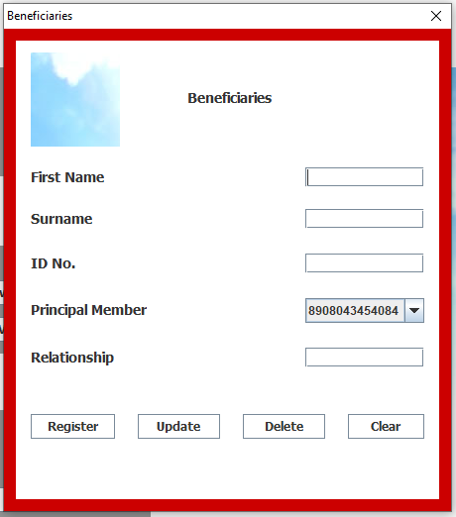

* **Register** – this button uploads to the database details of a beneficiary being registered under a policy of a principal member. The principal member that the beneficiary is registered under is chosen from the **principal member** field, or rather their ID number is chosen.
* **Update** – this button sets to the GUI details of a beneficiary being updated, the button then changes its text to **save**. When the text is **save**, the button saves to the database updated details of a beneficiary.
* **Delete** – this button deletes from the database details of a beneficiary.
* **Clear** – this button clears text in the GUI text input fields.

* **View Beneficiaries** – this button displays a form that displays details of registered beneficiaries, the form also provides a search functionality.

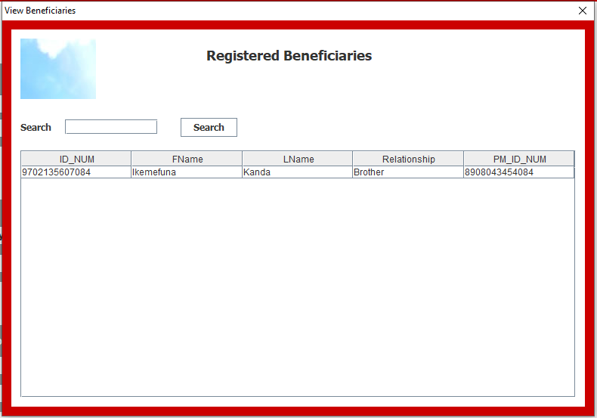

* **Search** – this button searches the database for a beneficiary using their first and last name or one of the two. It the displays the results on the table and changes its text to **clear**. When the button text is **clear** and gets selected, it clears the search text box and updates the table to display all beneficiaries again.
* **Update Account** – this button of the main application window displays a form dialog to update login account details of the current logged in administrator.

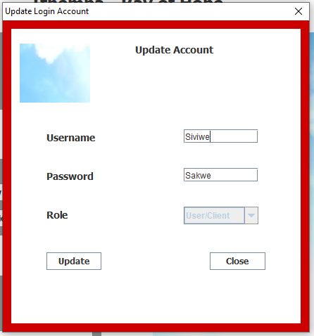

* **Update** – this button uploads to the database updated login account details of the currently logged in administrator.
* **Close** – this button disposes of this form.
* **Delete** **Account** – this button deletes the login account of the current logged in administrator, then logs out the administrator.
* **Logout** – this button logs out the logged in administrator.
* **The Selection form** – this form dialog is brought up when an administrator updates policy covers, principal members, or beneficiaries. Also, when an administrator wants to delete one of the principal members or one of the beneficiaries. It is also utilised when a principal member wants to update or delete details of beneficiaries registered under them (the principal member).

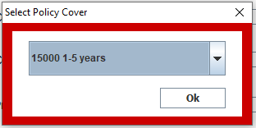

* **Ok** – when the dialog is displayed from the covers form, this button sets details of the selected cover to the GUI of the covers form.

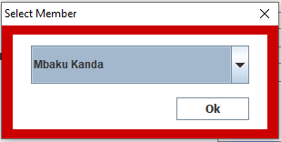

* **Ok** – when this dialog is displayed from the policy registering and management form for purposes of updating policy details of a principal member, this button sets to the GUI details of the policy. If it is displayed for purposes of deleting one of the principal members, this button fetches from the database a unique identifier that is used to delete the selected principal member.

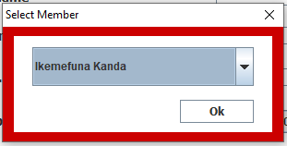

* **Ok** – when this dialog is displayed from the beneficiaries management form for purposes of updating details of a beneficiary, this button sets to the GUI details of the selected beneficiary. If it is displayed for purposes of deleting one of the beneficiaries, this button fetches from the database a unique identifier that is used to delete the selected beneficiary.

**User / Client**

When a user / client is logged in, the Main application window is displayed as follows:

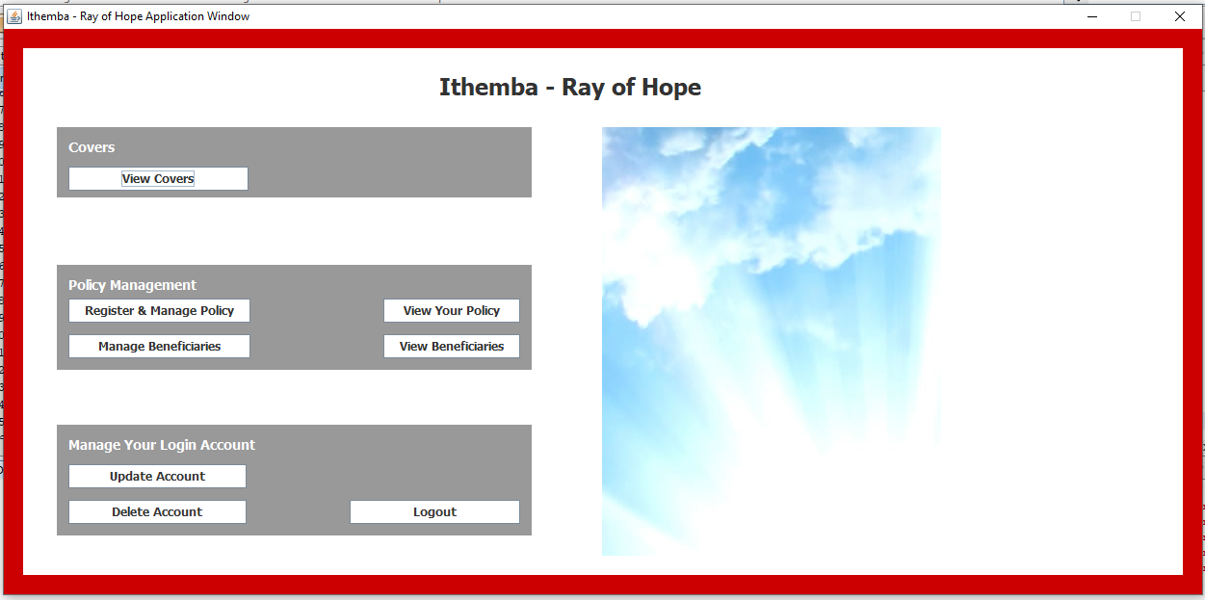

* **View Covers** – this button displays a form to display policy covers offered by the burial society, as seen documented above.
* **Register & Manage Policy –** this button displays a form for user/client to register for a policy and also manage their policy details.

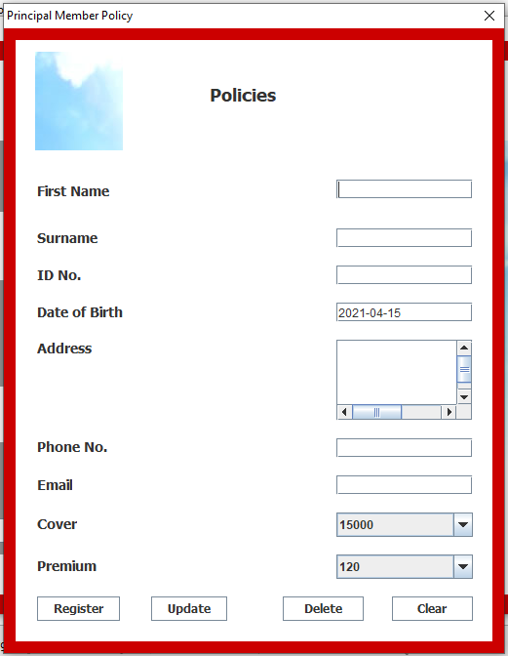

* **Register** – this button uploads to the database policy details of a registering client.
* **Update** – this button sets to the GUI policy details of the logged in client (if the client has already registered for a policy), the button then changes its text to **save.** When the text is **save**, the button uploads to the database details of the updating client.
* **Delete** – this button deletes policy details of the logged in client (if the client has already registered for a policy). It also deletes all the beneficiary records registered under this client, if there are any.
* **Clear –** this button clears text in the GUI text input fields.
* **View Your Policy** – this button displays a form that shows policy details of the logged in client.

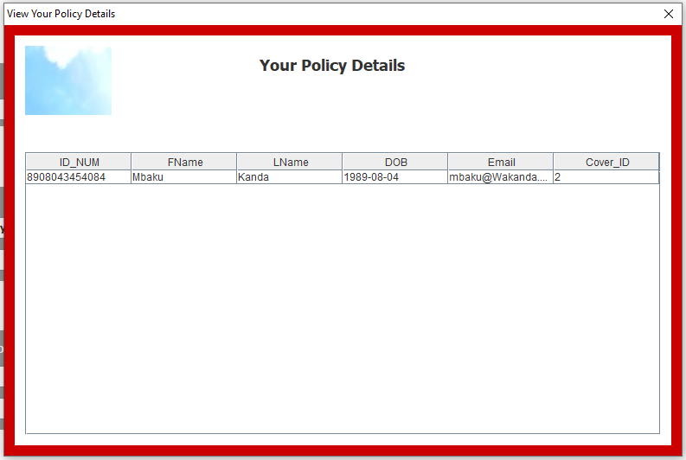

* **Manage Beneficiaries**  - this button displays a form for the client (principal member) to register under their policy, beneficiaries. As can be seen from the **principal member** field, only the ID number of the logged in client is displayed.

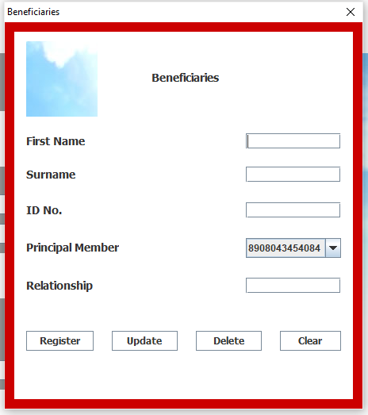

* **Register** – this button uploads to the database details of the beneficiary being registered.
* **Update** – this button allows a client (principal member) to update details of beneficiaries registered under their policy.
* **Delete –** this button allows a client to delete details of beneficiaries they have registered under their policy.
* **Clear** – this button clears text in the GUI text input fields.
* **View Beneficiaries** – this button displays a form that displays beneficiaries registered under the policy of the logged in client.

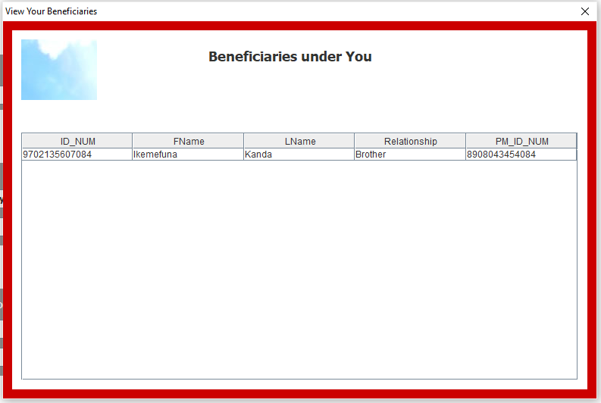

* **Update Account** – as documented above in this document, the button displays a dialog form for the currently logged in user/client to update their login account details.
* **Delete Account** – this button deletes login account details of the currently logged in user/client, it then logs out that user.
* **Logout** – this button logs out a currently logged in user/client.